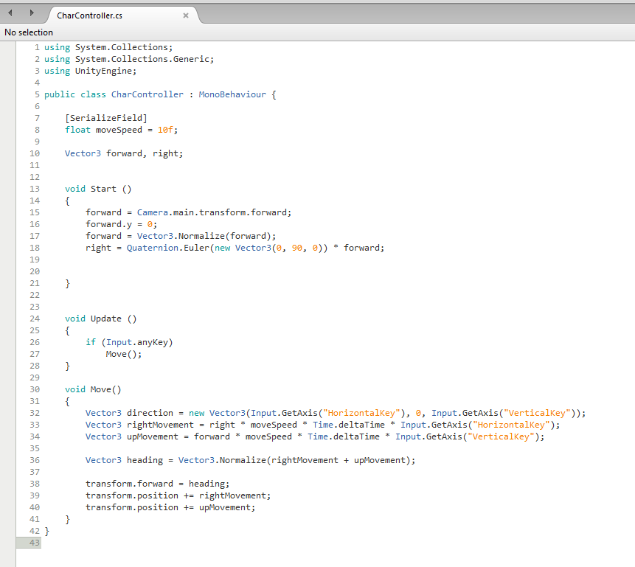­­­­­­Isometric Movement

SerializeField Is used to show a private variable’s value on Inspector. You can change it like you can with a public variable, but you cannot access the value from another script.

Float moveSpeed – 10f; This is used to determind the speed of the object the script is attached to.

Vector3 forward, right; Used for dictating the players forward and right movement via the Isometric plane

Forward = Camera.main.transform.foward; The forward vector is going to equal the cameras vector, this aligns the objects axis with the cameras axis.

Forward.y = 0; Clarifying the the y vector is always going to be set to 0.

Forward = Vector3.Normalize(forward); This keeps the vectors direction but sets the length to 1 or 0 depending on the factors this ensures that the length is set to 1 and will be used for motion.

Right = Quaternion.Euler(new Vector3(0, 90, 0)) \* forward; Quaternion.Euler is creating a rotation for the right vector telling it to be rotated 90degrees around the x axis and then multiply it along the forward vector which will result in a right vector that is facing -45 degrees from the world x axis

If (Input.anyKey) Move(); Detects if any key has been pressed and will execute the move function.

Vector3 direction…; The new direction is equal to whatever the value the input of the x and y values at any given time. (Horizontal positive key is D and negative is A. Vertical positive is W and negative is S)

Vector3 rightMovement…; What the right and left movement is going to be. This has been referenced further up and then is multiplied by the move speed, then by ‘Time.deltaTime’ to give it a smoother movement then multiplying all of that by ‘horizontalKey’ to move it in a positive or negative direction.

Vector3 upMovement…; What the up and down movement is going to be. This has been referenced further up and then is multiplied by the move speed, then by ‘Time.deltaTime’ to give it a smoother movement then multiplying all of that by ‘verticalKey’ to move it in a positive or negative direction.

Vector3 heading…; Combining right and up to give total movement, letting the object move along any axis in the world.

Transform forward = heading; To equal the heading so it doesn’t move on the worlds z axis. So it follows the rightward and upward movement this causes the rotation of the world

Transform position += rightmovement/upmovement; This is what makes the actual movement happen.